Fitting bremsstrahlung and source Compton lines
GeoPIXE fitting has been improved to better track bremsstrahlung "fitting" in DA imaging and to now better fit the Compton scattered peaks from the In and Sn K lines from the Excillum source. This includes some changes to existing fitting controls. Available in GeoPIXE version 7.5s.

Bremsstrahlung and DA
To allow the large hump from the source bremsstrahlung, filtered using 1 mm of Al, to vary in the effective "fit" that occurs during DA image projection, the background can now be split into two components. The split is enabled on the Advanced/Back2 tab in the X-ray Fitting window. Once split, the two background components vary independently with position across a scan area to better track the changing intensity of the bremsstrahlung and background at lower energies.
This should be enabled for all DA imaging of Maia Mapper data and can be beneficial for synchrotron data as well. The energy at which the split is performed is set by the "Split energy" value. A value of 10 keV works well for Maia Mapper.
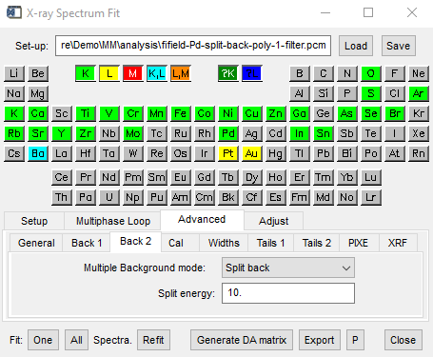

Source Compton lines
Compton scattering of the In K and Sn K lines from the Excillum source off the sample produces prominent features on the bremsstrahlung hump. This becomes stringer for light element targets (e.g. epoxy). Once In K and Sn K lines are enabled in the fit, the Compton peaks are added automatically for the continuum source. Their position and distribution in energy can be modified, as for SXRF, using the "Shift" and "Spread" controls on the Advanced/XRF tab. "Shift" adjusts the electron momentum distribution, larger values move the Compton peaks left, smaller values move them right. "Spread" changes the width of the Compton peaks. Note that for Maia Mapper, use only small values for the Compton tail (e.g. 0.1 or less).
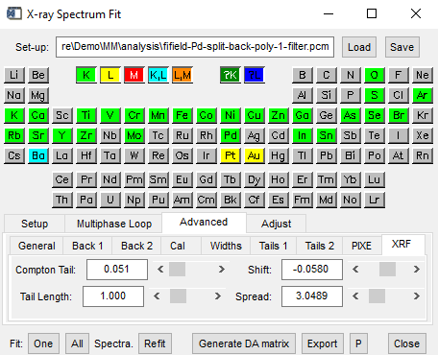
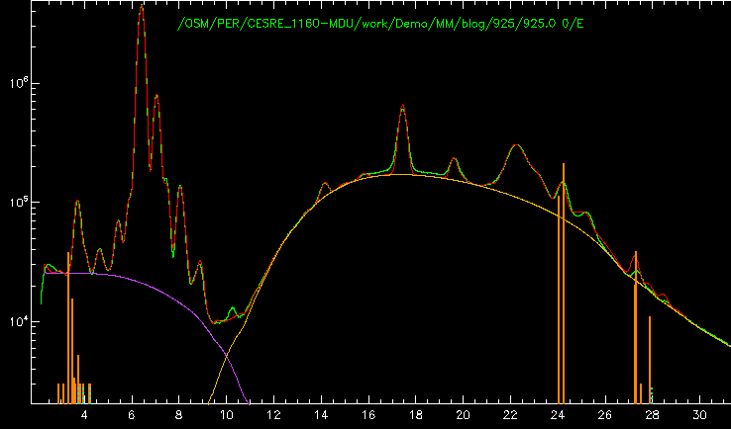
XRF peak controls (left), run #925 spectrum fit (see Demo data) showing split background and Compton peaks (to left of marked In K lines) (right)

